Written by: Daniela Herrera

Date: March 2020

To use the MATLAB scripts, the following image shows the folder structure that must be followed in order to run the scripts. As of now, the post processing scripts only process Dynamic and Static Tests. MaxG data must be analyzed individually. This can be easily done in excel by plotting time vs grip force and identifying where the peaks are.

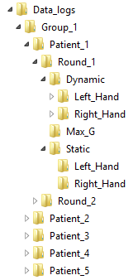

These folders must be made manually. Future students can create a script that generates these automatically.

Folder conventions

Groups

* Group 1: Control group
* Group 2: MS group

Patients

* Patient_1 through Patient_n: Patient identities are kept safe by assigning a patient with and ID. Use that ID to name their folder in which you will store all their data.

Hand used during testing

* Left_Hand
* Right_Hand

Tests

* Dynamic
  + 0g
  + 450g
* Static
  + LabVIEW will automatically assign a ‘0g’ tag by default. In reality, I only added this tag to differentiate if weight was used for that test. This can be ignored for this test and only applies for dynamic testing.
* MaxG
  + LabVIEW will automatically assign a ‘0g’ tag by default. In reality, I only added this tag to differentiate if weight was used for that test. This can be ignored for this test and only applies for dynamic testing.

Running the scripts

Make sure to download all of the scripts and keep them in the same folder. The main script you will be running is called “postProcessData_FINAL.” The only variables or items you are to change are in lines 10 through 13. See image below.

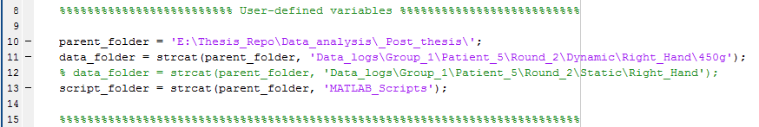

You don’t need the ‘parent_folder’ variable. I used it for my convenience. You can delete that variable if you wish. For the ‘data_folder’ variable, you must specify the individual test subfolder where your raw data text files are located. Examples of individual tests folders are listed below in bullet points.

* \Round_1\Dynamic\Left_Hand\0g
* \Round_1\Dynamic\Left_Hand\450g
* \Round_1\Dynamic\Right_Hand\0g
* \Round_1\Dynamic\Right_Hand\450g
* \Round_1\Max_G\Left_Hand
* \Round_1\Max_G\Right_Hand
* \Round_1\Static\Left_Hand
* \Round_1\Static\Right_Hand
* \Round_2\Dynamic\Left_Hand\0g
* \Round_2\Dynamic\Left_Hand\450g
* \Round_2\Dynamic\Right_Hand\0g
* \Round_2\Dynamic\Right_Hand\450g
* \Round_2\Max_G\Left_Hand
* \Round_2\Max_G\Right_Hand
* \Round_2\Static\Left_Hand
* \Round_2\Static\Right_Hand

If you look closely at the string assigned for ‘data_folder’, you will see that it follows the folder structure from above. The post processing scripts use this folder structure to identify which MATLAB functions it will use and how to process the data. Lastly, the ‘script_folder’ variable stores the location of your MATLAB scripts.

These scripts will only work if the user does not change the naming convention in the LabVIEW VIs. If changes are made in LabVIEW, the user must reflect those changes in MATLAB.

ICC analysis

For ICC analysis, run the script under the name of “run_ICC_analysis.” To run this script, I used Excel to organize my Matrix of data I analyzed and copied that Matrix directly in variable ‘M’ in line 6. This should be the only variable you modify in this script.

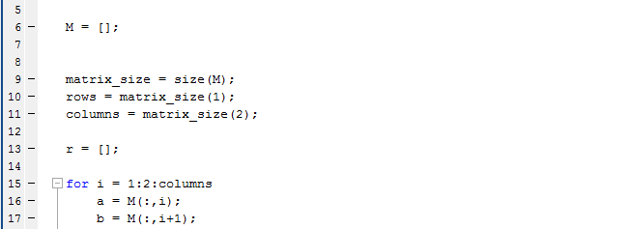

Feel free to make any modifications or your generate own scripts.